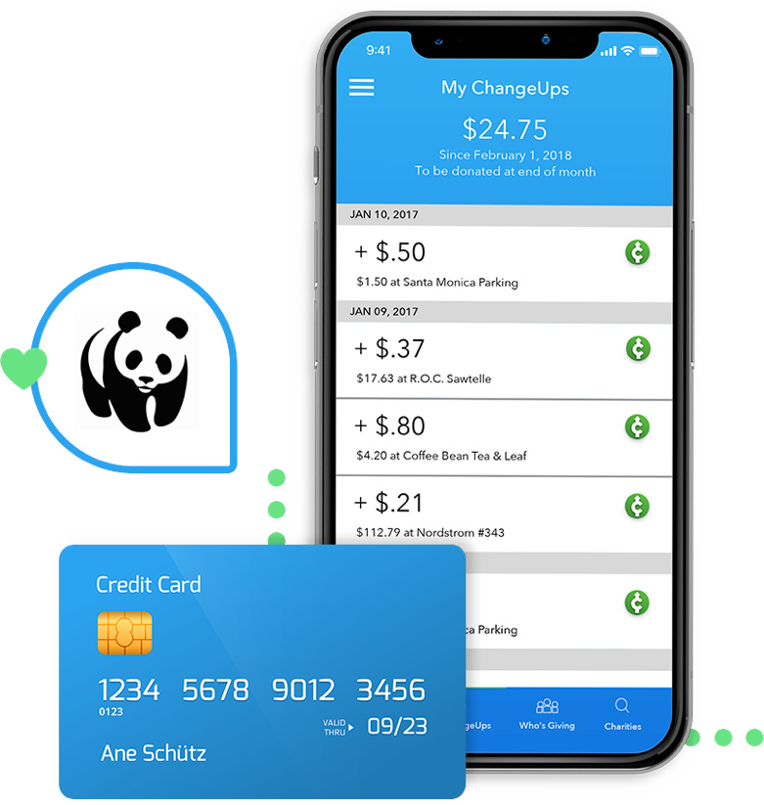Round-Up Your Purchases and Send the Spare Change to Us!

Point iPhone Camera

Android Smartphones
Download for free and ChangeUp
will give us $1 now!
Link any credit card or debit card
Our partner ChangeUp will automatically round-up every purchase you make, online or off, and send the change to us!
Set mins and maxes
Instant reports on your tax- deductible giving

