**Round-Up Your Purchases and Send the Spare Change to Us!**

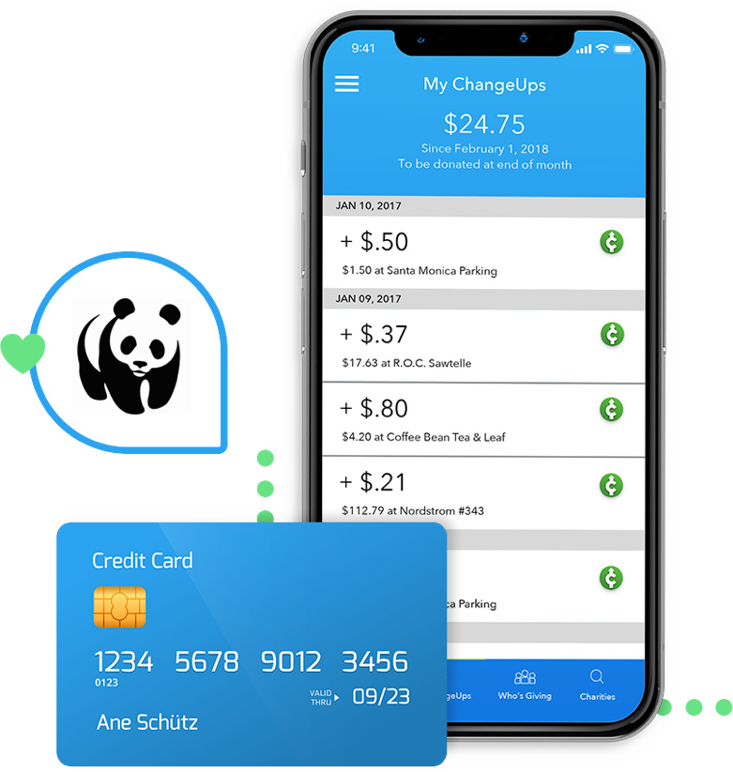

**Point iPhone Camera**

**Android Smartphones**

Download for **free** and **ChangeUp**

will give us **$1 now!**

Link any credit card or debit card

Our partner **ChangeUp** will automatically round-up every purchase you make, online or off, and send the change to us!

Set mins and maxes

Instant reports on your tax- deductible giving